Dear Young Warrior Society Sponsor, July 2021
My name is Nancy and I am the director of SHARP Kids, an out of school time program in the Grand Coulee Dam/Nespelem area. This program is funded by a federal grant called 21st Century Community Learning Center.
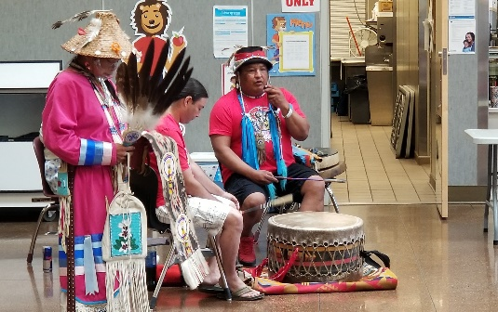
On July 8th, 2021, our summer SHARP Kids program facilitated a Native Cultural Awareness celebration. The celebration featured 5, half-hour sessions including Salish language, Story Circles using hieroglyphics, storytelling by a local native elder, hide tanning, and stick games. We concluded the day with a 60 minute Pow Wow. Dan Nanamkin sang and drummed with his cousin while MCing the Pow Wow. It was a very special time for all of the children, staff, and many others who gathered to participate in the celebration. The students were completely engaged and fully participated as Dan skillfully kept their attention. Dan has a unique ability to draw young people in and challenge them to treat people with honor, respect and kindness.
I highly support Dan and his desire to work with our youth to raise them up as Young Warriors who care about their culture, heritage, and community.
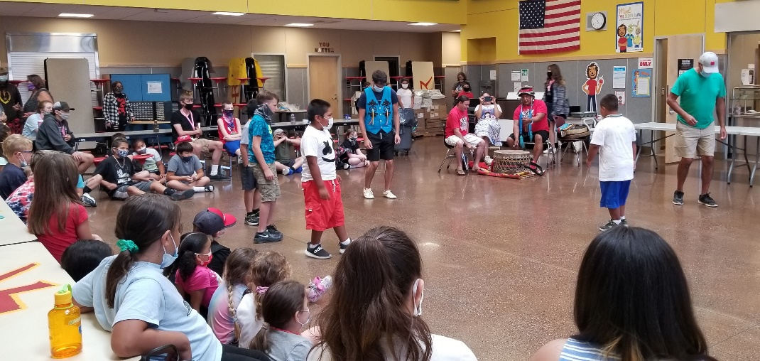
Sincerely,
Nancy Kuiper

